**Lab 2 – Amazon EMR and University Hadoop System**

**Aim:**

1. Compile a java file to make it executable
2. Check the Data loss using checksum
3. Using the university Hadoop system to do parallel processing

**1. Run the commands in Amazon EMR for Example 3-1 and paste the outputs in the following :**

(1). javac -cp src/:hadoop-common-2.6.1.jar:hadoop-mapreduce-client-core-2.6.1.jar:commons-cli-2.0.jar -d . URLCat.java

(2). hadoop URLCat hdfs:///user/hadoop/quangle.txt

Answer:

hadoop URLCat hdfs:///user/hadoop/input0/quangle.txt

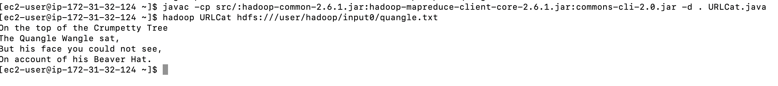

**2. Run the commands in Amazon EMR for Example 3-2 and paste the outputs in the following :**

(1). javac -cp src/:hadoop-common-2.6.1.jar:hadoop-mapreduce-client-core-2.6.1.jar:commons-cli-2.0.jar -d . FileSystemCat.java

(2). hadoop FileSystemCat hdfs:///user/hadoop/quangle.txt

Answer

hadoop FileSystemCat hdfs:///user/hadoop/input0/quangle.txt

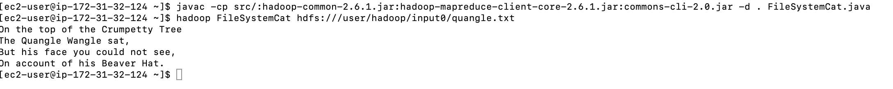

**3. Run the commands in Amazon EMR for checksum of two files and paste the outputs in the following:**

(1). hdfs dfs -copyToLocal /user/hadoop/quangle.txt quangle.copy.txt

md5sum quangle.txt quangle_copy.txt

Answer

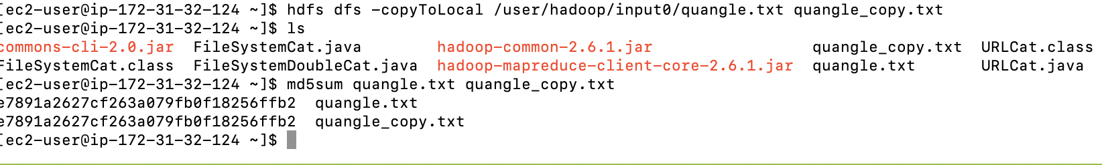

**4. Connect to the University Hadoop System and paste the outputs in the following:**

Answer

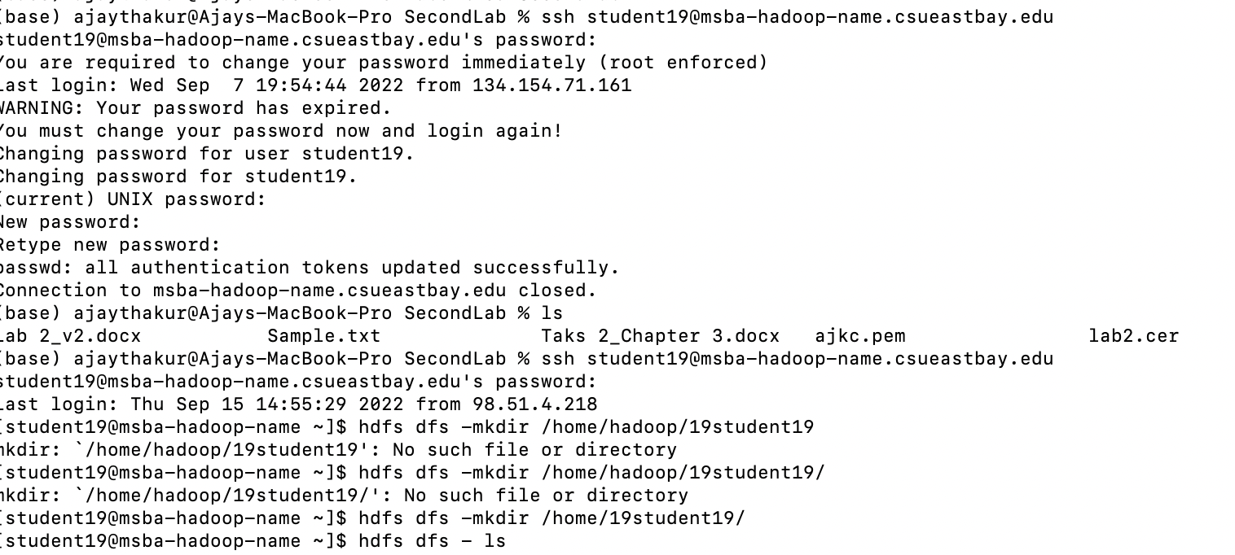

**5. Create a jar file after running the following command in the University Hadoop System, and paste the outputs indicating the jar file below:**

(1).jar -cvf max-temperature.jar ./MaxTemperature*.class

*(-c – create new archive; -v – generate verbose output on standard output; -f – specify archive file name)*

Answer

**6. After executing the max-temperature jar in the University Hadoop System, copy and paste the screenshot of output contents using “-c”:**

(1). hadoop jar max-temperature.jar MaxTemperature /home/19student19/input0/ /home/19student19/output0/

Answer

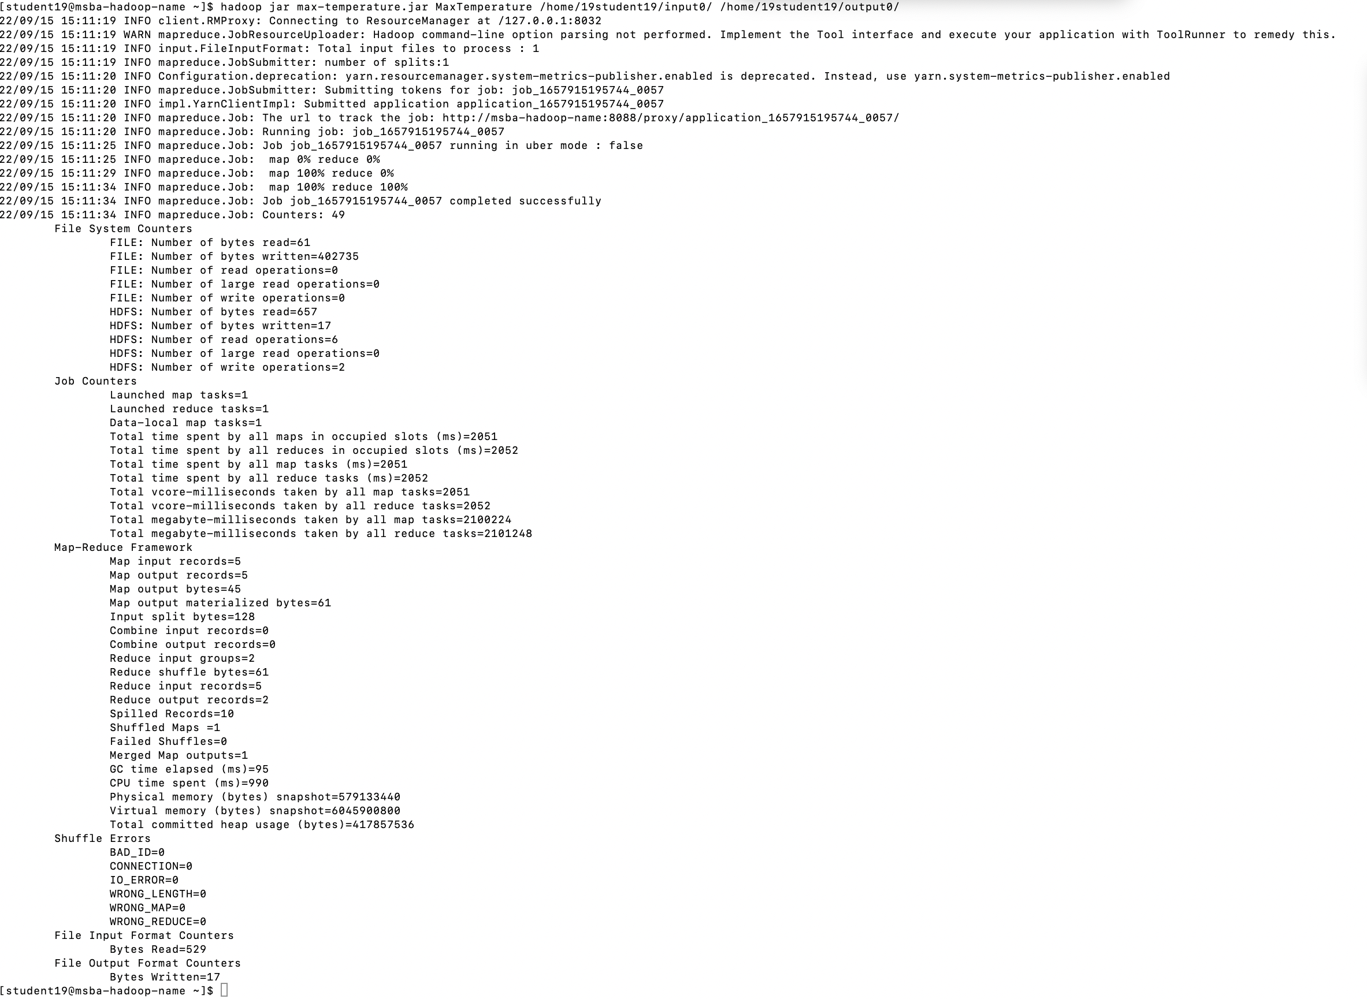

(2). hdfs dfs -cat /home/jwu/chapter2/output3/part-r-00000

hdfs dfs -cat /home/19student19/output0/part-r-00000

Answer

